**Audio Player Middleware Component Development**

| Author | Prachi Verma |
| --- | --- |
| Version | V1.0 |
| Date | 12-01-2023 |

Revision History

| Date | Change | Author | Version |
| --- | --- | --- | --- |
| 11-01-2023 | Documentation not added | Prachi Verma | V1.0 |
| 12-01-2023 | Static Analysis added | Prachi verma | V1.0 |
|  |  |  |  |

Contents

**1.** **Introduction to Software Development Process** 3

**2.** **Software Requirement** 4

**3.** **Software Design** 5

2.1 High Level Design 5

2.1.1 Objective 5

2.1.2 Block diagram and components 5

2.2 Low Level Design 6

2.2.1 Defines 6

2.2.2 Data Structure 7

2.2.3 APIs 7

2.2.4 State Machine 9

**4.** **Software Development/Implementation** 10

**5.** **Software Verification and Validation** 11

5.1 Verification 11

5.1.1 Static Analysis 11

5.1.1 Unit Testing 11

5.1.1.1 Test cases 11

5.1.1.2 Test Results 11

5.1.1 Review 12

5.2 Validation 12

5.2.1 Functional Testing 12

5.2.2 Integration Testing 12

5.2.3 System Testing 12

# **Introduction to Software Development Process**

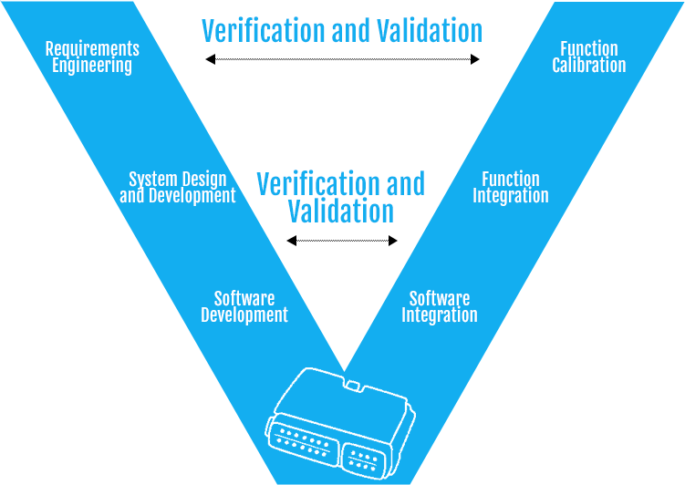

Software Development Process ( V-Model)

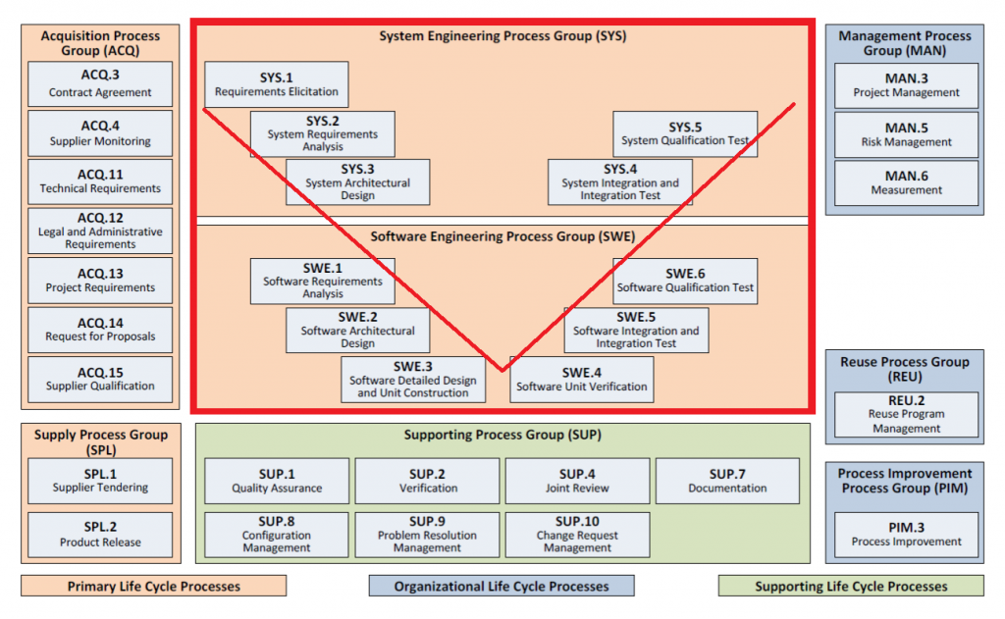

Software Development Process – Automotive SPICE

# **Software Requirement**

* APLAYER_R_001: To develop a music player middleware API to HMI
* APLAYER_R_002: It shall provide an API to select an audio file source
* APLAYER_R_003: It shall provide an API to play an audio file source
* APLAYER_R_003: It shall have an API to stop an audio file source

# **Software Design**

This section describes the High-Level design of mplayer module.

## 2.1 High Level Design

## 2.1.1 Objective

<Write down the objective>

## 2.1.2 Block diagram and components



<List down the components and give a short description>



<List down the components and give a short description>

## 2.2 Low Level Design

This section provides details of Low level design.

## Defines

#define ***PLAYER_SOURCE_LEN 128***

Defines key event

**typedef enum {**

AKEY_STOP,

AKEY_START,

AKEY_INVALID

**}PlayerKey_e;**

Defines player states

**typedef enum {**

ASTATE_INIT,

ASTATE_IDLE,

ASTATE_PLAYING

**} PlayerState_e;**

## Data Structure

***struct PlayerSource_st {***

*char strSource[PLAYER_SOURCE_LEN];*

*int nCurrentOffset;*

***}***

***struct Player_st {***

*PlayerState_e eCurrentState;*

*struct PlayerSource_st stPlayerSource;*

**}**

## APIs

Syntax : **Player_st *PlayerInit(void);**

Parameters (in) : none

Parameters (out) : none

Return value :Player_st*

Description : this function will allocate memory dynamically

initialize eCurrentState .

Syntax :**struct Player_st *PlayerSelectSource( struct Player_st *pstPlayer, char *strSource)**

Parameters (in) : Player pointer, source file name.

Parameters (out) : it will print which source source file is selected

Return value : it will return pstPlayer pointer to structure

Description : the function will take player structure and file name and assigne it to strSource n variable of stPlayerSource struct .

Syntax : **void PlayerSMHandle(struct Player_st *pstPlayer,**

**PlayerKey_e eKeyPressed)**

Parameters (in) : player_st structure and eKeyPressed

Parameters (out) : based on the key user pressed it will print wether song

is playing or it is paused.

Return value : void

Description : This function will take player_st structure and key

pressed by user and it will asssign this state

eCurrentState depending upon what state user gave.

Syntax :  **void PlayerDeInit(struct Player_st * pstPlayer)**

Parameters (in) : pstPlayer structure

Parameters (out) : none

Return value : void

Description : this function will free the player structure memory

allocated when we called init function.

## State Machine



* Pseudo-code
* Files Organizations

# **Software Development/Implementation**

See the source code files.

# **Software Verification and Validation**

## Verification

## 5.1.1 Static Analysis

| File Name/Line Number | MISRA C Error | Status | Fix | Comment |
| --- | --- | --- | --- | --- |
|  |  |  |  |  |
|  |  |  |  |  |
|  |  |  |  |  |

## 5.1.2 Unit Testing

## 5.1.2.1 Test cases

| TestID | Test Case | Pre-condition | Steps | Expected Results |
| --- | --- | --- | --- | --- |
| 1. | Select a .mp3 file | Check if file is .mp3 or not | 1.Take input as a string.  2.String must contain .mp3  3.Accept the file  4.Else reject | if file given have .mp3 then it will work and ask for other options. |
| 2. | Use Player Or not | To Use the player you have to choose 1. | 1.Take input as 1 to use player. | Player will start |
| 3. | Stop Player | choose any value other than 1 | press any value | player will stop  and prints error. |

## 5.1.2.2 Test Results

| TestID | Test Case | Pre-condition | Steps | Expected Results | Actual Results | PASS/FAIL |
| --- | --- | --- | --- | --- | --- | --- |
| 1. | Select a .mp3 file | Check if file is .mp3 or not | 1.Take input as a string.  2.String must contain .mp3  3.Accept the file  4.Else reject | if file given have .mp3 then it will work and ask for other opti | .mp3 | PASS |
| 2. | Use Player Or not | To Use the player you have to choose 1. | 1.Take input as 1 to use player. | 1.Take input as 1 to use player. | Player will start | PASS |
| 3. | Stop Player | choose any value other than 1 | press any value | player will stop  and prints error. | player will stop | PASS |

## 5.1.3 Review

Review records

| File Name/Line No | Review comment | Status | Comments |
| --- | --- | --- | --- |
|  |  |  |  |
|  |  |  |  |

## Validation

## Functional Testing

## Integration Testing

## System Testing